|  |
| --- |
|  |
| PLC BASED PYROLATIC CHAMBER  INDUSTRIAL CONTROL ELECTRONICS PROJECT |
| |  |  |  | | --- | --- | --- | | ENGR. UMAIRA SHAHID | ELECTRONIC ENGINEERING DEPARTMENT | SIR SYED UNIVERSITY OF ENGINEERING & TECHNOLOGY | |

**BIO GREEN ENERGY BASED PYROLATIC CHAMBER**

**INDUSTRIAL CONTROL ELECTRONICS (EE_461)**

**Submitted by**

**KASHAN IQBAL 2017-EE-067**

**MUHAMMAD HASSAN 2017-EE-069**

**UMAMA RATEEB 2017-EE-070**

**AAZIB AHMED ANSARI 2017-EE-078**

**MIRZA HAMZA UMER 2017-EE-079**

**MUAMMAD USMAN 2017-EE-107**



**7th Semester Project Report**

Department of Electronic Engineering

Sir Syed University Of Engineering and Technology, Karachi

**ACKNOWLEDGEMENT**

We would like to express our deepest appreciation to all those who provided us the possibility to complete this project and report.  A special gratitude we give to our project teacher, **ENGR. UMAIRA SHAHID,** whose contribution in stimulating suggestions and encouragement, helped me to coordinate our project especially in writing this report.

Furthermore, we would also like to acknowledge with much appreciation the crucial role of **ENGR. RAIYAH** who gave the guidance to in our project and the necessary materials to complete the project. A special thanks goes to my Group Members who help me to assemble the parts and gave suggestion about the task. Last but not least, many thanks go to the head of the project, whose have invested his full effort in guiding the team in achieving the goal. I have to appreciate the guidance given by other supervisor as well as the panels especially in our project presentation that has improved our presentation skills thanks to their comment and advices.

**TABLE OF CONTENTS**

**Page**

**Acknowledgment** 02

**Table of Contents** 03

**List of Figures**  04

**List of Tables** 04

**Abstract** 05

1. **INTRODUCTION** 
   1. Introduction 05

* The Pyrolysis of Plastic
* Catalyst
* Compound Yielding Bio-Oils 06

1.2 Theoretical Background 07 Plastics

1. **PROJECT BLOCK DIAGRAM**

2.1 Block Diagram 07

2.2 Description of Blocks 08

1. **METHODOLOGY**

3.1 Working of the Circuit 08

1. **OBSERVATIONS & RESULTS** 09
2. **CONCLUSION & FUTURE RECOMMENDATION** 09

**REFRENCES** 10

**APPENDIX A: Cost Analysis of the Project** 11

**LIST OF FIGURES**

**Page**

Figure 1.1 Plastic Bottles  05

Figure 1.2 Plastic Yields 06

Figure 1.3 Plastic to Fuel 06

Figure 1.4 Structure of Polystyrene 07

Figure 2.1 Block Diagram 07

Figure 2.2 Plastic Processing 08

Figure 3.1 Process Diagram 08

Figure 5.1 Observations & Results 09

**LIST OF TABLES**

**Page**

Table 1.1 Hydro-Carbon range in commercial Fuels 06

**ABSTRACT**

Waste plastic disposal and excessive use of fossil fuels have caused environment

concerns in the world. Both plastics and petroleum derived fuels are hydrocarbons that

contain the elements of carbon and hydrogen. The difference between them is that

plastic molecules have longer carbon chains than those in LPG, petrol, and diesel fuels.

Therefore, it is possible to convert waste plastic into fuels.

The main objectives of this study were to understand and optimize the processes of

plastic pyrolysis for maximizing the diesel range products, and to design a continuous

pyrolysis apparatus as a semi-scale commercial plant. Pyrolysis of polyethylene (PE),

polypropylene (PP), and polystyrene (PS), the pyrolysis reaction consists of three progressive steps:

initiation, propagation, and termination. Initiation reaction cracks the large polymer

molecules into free radicals. The PE pyrolysis products are mainly 1-alkenes, n-alkanes, and α, ω- alkenes ranging

from C1 to C45+. The 1-alkenes and the n-alkanes were identified with a special method

developed in this research. The oil produced has very high quality and close to the

commercial petroleum derived liquid fuels. The experience of design and operation of

the semi-scale plant will be helpful for building a commercial scale plant in the future.

So, here we have made a small process plant using PLC which will give an efficient amount of yield of Bio-Fuels and which is safe to use because it is automatically operated without the interference of the humans.

**INTRODUCTION**

* 1. **Introduction:**

**The Pyrolysis of Plastic Materials:**

Pyrolysis is a thermal cracking reaction of the large molecular weight polymer carbon

chains under an oxygen free environment and produces small molecular weight

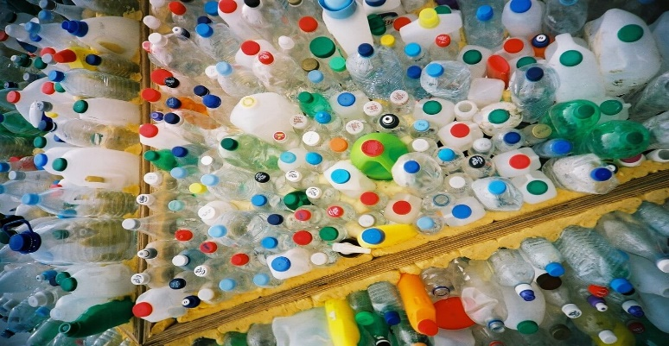 molecules.

**Figure 1.1 Plastic Bottles**

**Catalyst:**

catalysts are also used to improve the quality of pyrolysis products in many existing equipment. These equipment’s with catalysts have some weakness in terms of long material resistance time, undesired contact between plastics and catalysts, required high 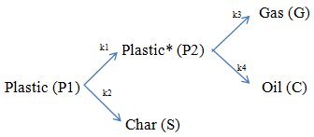heat transfer rate, and cost of the catalysts.

**Figure 1.2 Plastic Yields**

**Compounds Yielding Bio-oils:**

Paraffin’s are saturated hydrocarbons with straight or branched carbon chain, which are also called “alkane”. Olefins have similar chain as paraffin’s, but they have one or more multiple bonds between carbon atoms in their chains. Naphthenic are saturated hydrocarbons like paraffin’s but their chains merge to a ring in their structure. Aromatics contain a benzene ring in the structure. Another common way to describe the hydrocarbons is based on the carbon numbers in their molecule structure. The complex

pyrolysis products may also be grouped as petroleum gases, petrol, kerosene, diesel and wax.

The above fuels contain hydrocarbon group with different carbon chain lengths as

given in Table 1.1.

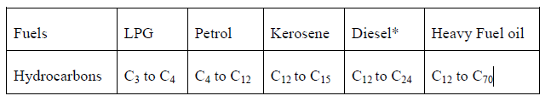

**Table 1.1 Hydrocarbon range in commercial fuels.**

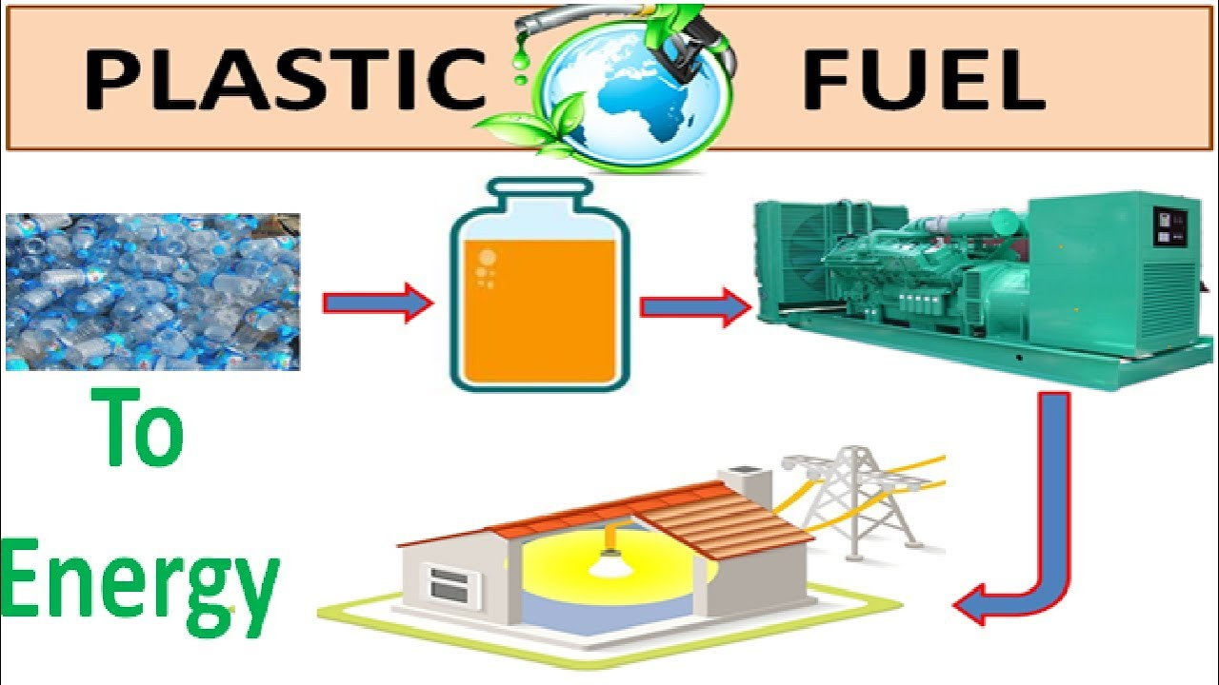

**FIGURE 1.3 Plastic to Fuel**

* 1. **Theoretical Background:**

**PLASTICS:**

Plastic is a high molecular weight material that was invented by Alexander Parkes in

1862. Plastics are also called polymers. The term polymer means a molecule made

up by repetition of simple unit. For example, the structure of polystyrene can be written

in a form as shown in Figure.

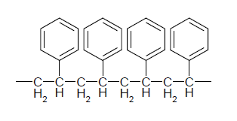

**FIGURE 1.4 Structure of Polystyrene**

**PROJECT BLOCK DIAGRAM**

* 1. 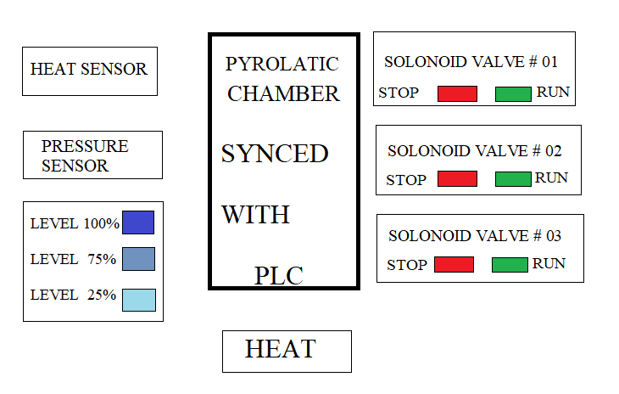**Block Diagram:**

**FIGURE 2.1 Block Diagram of the circuit**

**2.2 Description of Blocks:**

**HARDWARE DESCRIPTION**

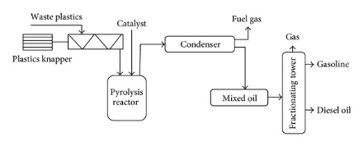Here, Heat sensor, Pressure sensor, and level indicators are the Inputs of the projects which are connected with the plc and the solenoid valves and indicators are the outputs of the projects and are also connected with the PLC. And the pyrolytic chamber is the sealed container which will yield the gases on giving a specific temperature to it.

**Figure 2.2 Plastic Processing**

**METHODOLOGY**

**3.1 Working of the Circuit(Controlling):**

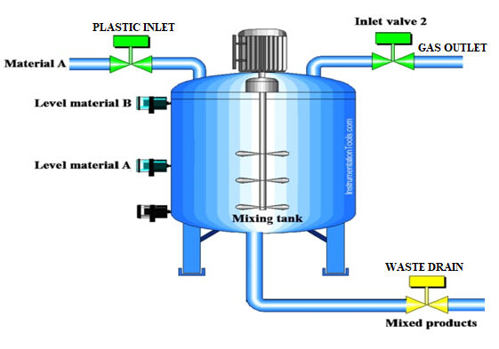 The Pyrolytic Chamber is sealed container having a shredded waste plastic which are thermal cracked in the presence of heat and in the absence of the Oxygen which will produce the Bio gas, the system working is as Level indicator indicates the 100% then the inlet valve

**FIGURE 3.1 Process diagram of the system**

is closed making it a sealed chamber then the flame is given to it and after few times when the temperature sensor indicates the specific temperature and pressure then the outlet valve is open to release the product gases and afterwards when the pressure decreases the drain valve is being opened to drain out the residue, this all process is being automated using a PLC.

**4. Observations & Results:**

**Ladder Diagram:**

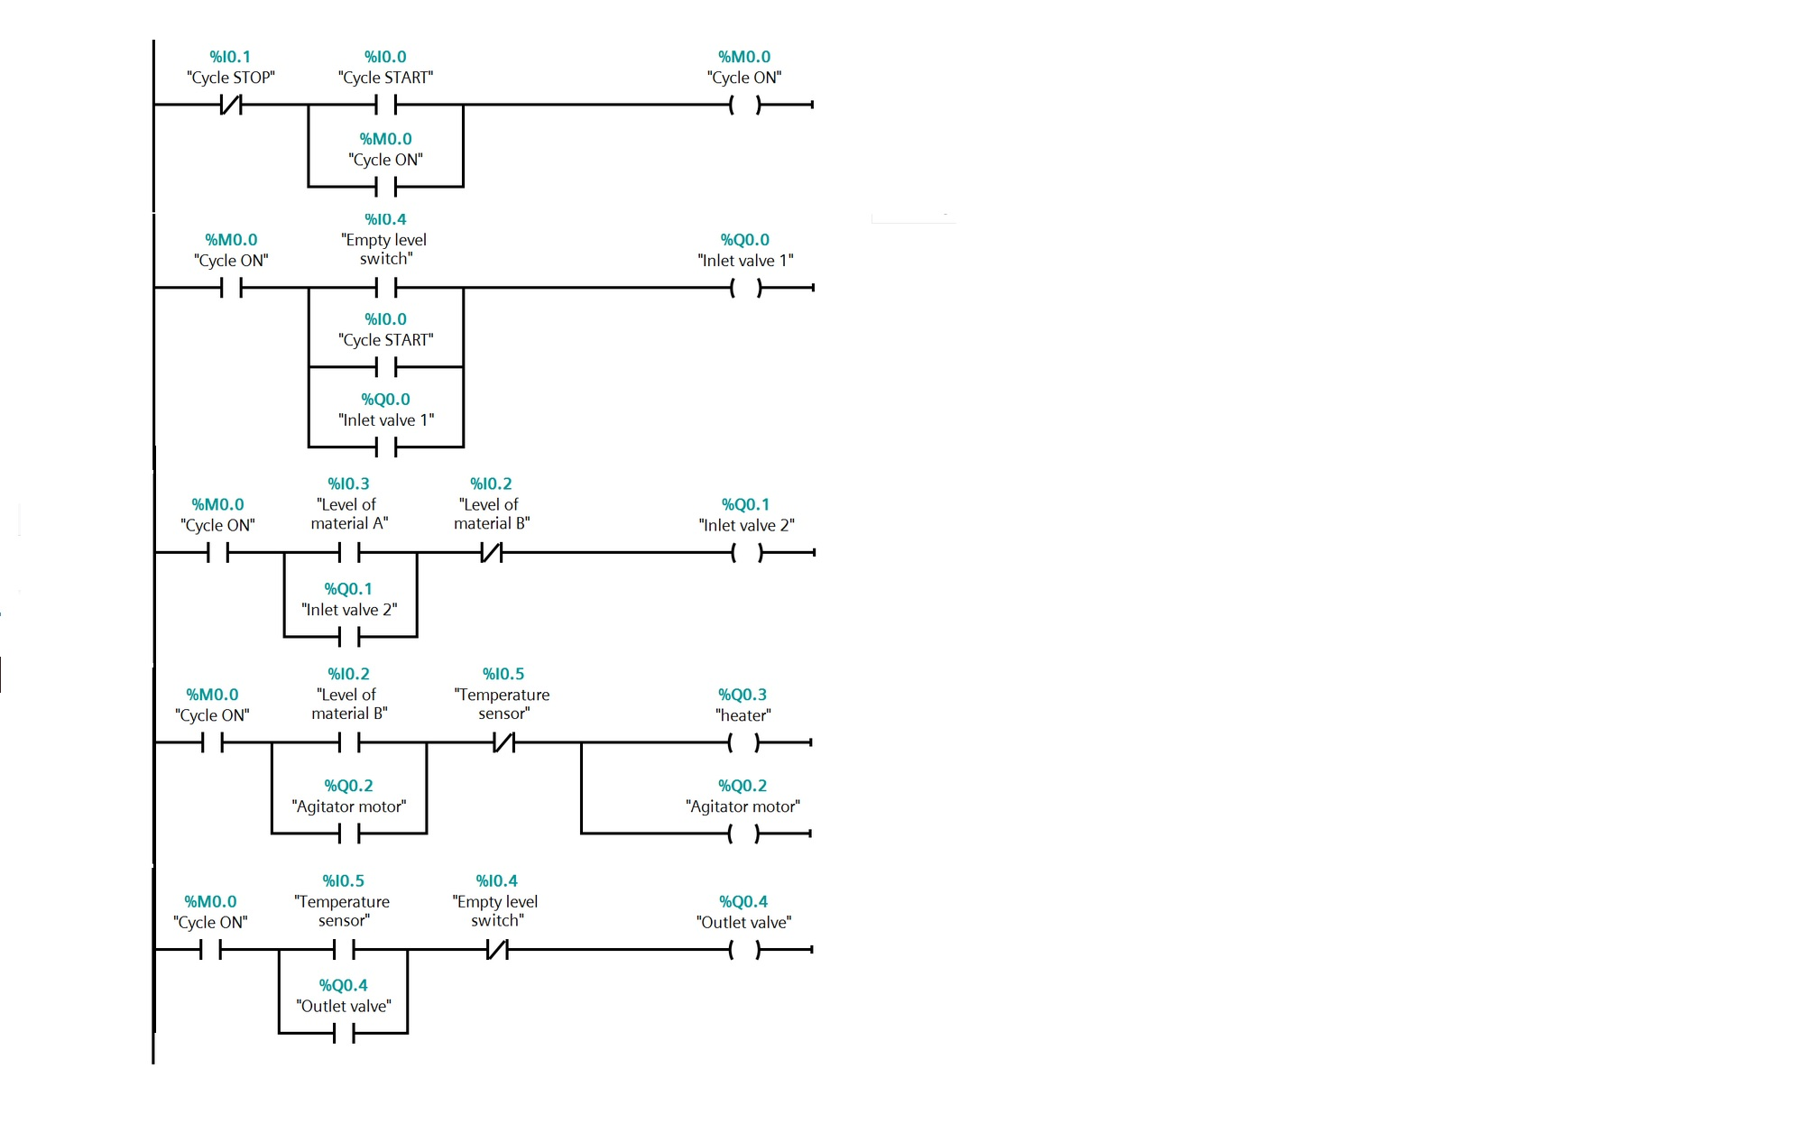

**4.1 Results:**

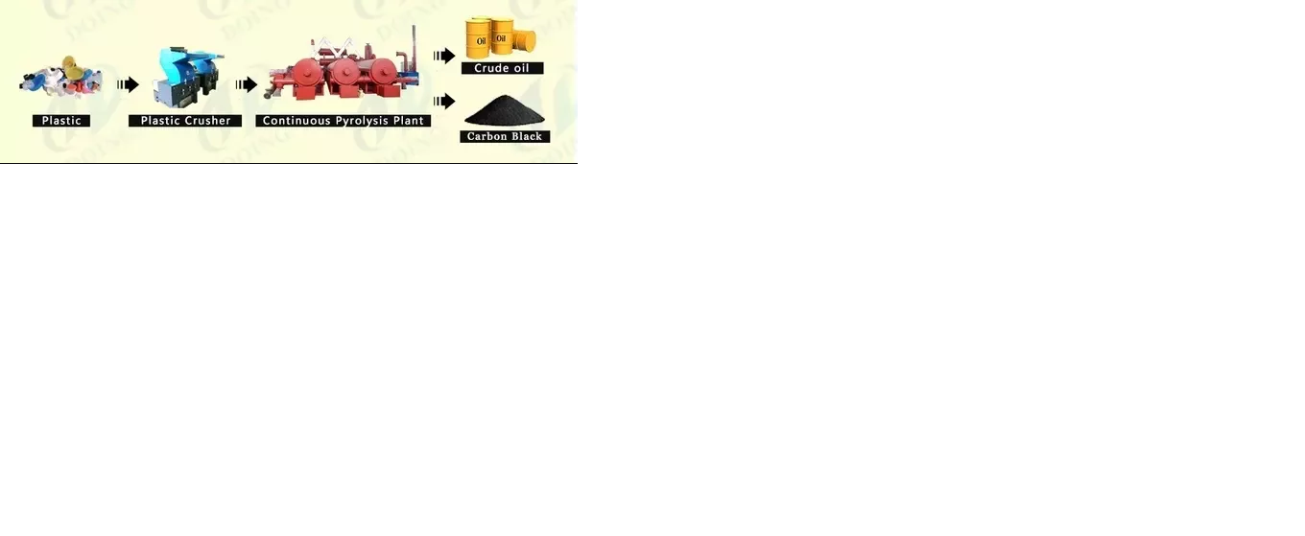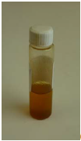The Bio-Fuel is being collected from the vessel which is about 10ml for about approx of 5kg of plastic . But is not the pure form it is to be refined to get the desired composition from that fuel. The following equation show the yields which we get from the thermal cracking of the plastic.

**FIGURE 4.1 RESULTS**

**5. Conclusions & Future Recommendations:**

Pyrolysis of hydrocarbon polymers is a very complex process, which consists of

hundreds of reactions and products. Several factors have significant effects on the

reactions and the products.

In order to commercialize the pyrolysis technology to recycling of the waste plastics

and to better understand the pyrolysis process, the following work is recommended

for further studies:

The **non-condensable gases** were flared off and the left over residue can be refined to get **pure carbon black** and **wax** can also be collected from the condenser in the experiment. It would be valuable to collect some of the gases and investigate its composition.

**REFRENCES**

[1]. Brydson, J.A. and ScienceDirect. *Plastics materials*. 1999 1999; Available

from: <http://www.sciencedirect.com/science/book/9780750641326>

[2]. Chanda, M., *Advanced polymer chemistry : a problem solving guide*. 2000,

New York [u.a.]: Marcel Dekker.

[3]. The Sociaty of the Plastic Industry, I. *SPI MATERIAL CONTAINER CODING*

*SYSTEM*. 1999 15/Sep/2008]; Available from:

<http://www.plasticsindustry.org/outreach/recycling/resincodes.htm>.

[4]. PlasticsEurope, *The Compelling Facts About Plastics 2007*. 2008: Brussels.

[5]. Engineering, N.Z.C.f.A., Regional Energy Survey 2006. 2008: Christchurch.

[6]. Kittle, P.A., Alternate Daily Cover Materials And Subtitled - The Selection

Technique. 1993, Rusmar Incorporated West Chester, PA.

[7]. Scheirs, J., Overview of Commercial Pyrolysis Processes for Waste Plastics,

in Feedstock Recycling and Pyrolysis of Waste Plastics, J.S.a.W. Kaminsky,

Editor. 2006, John Wiley & Sons, Ltd: Edithvale Australia. p. 399.

For more material type visit: <https://libguides.murdoch.edu.au/IEEE/all>

**APPENDIX-A**

**COST ANALYSIS OF THE PROJECT**

|  |  |  |  |  |
| --- | --- | --- | --- | --- |
| **MAJOR EQUIPMENT SPECIFICATION & COST** | | | | |
| **S.No** | **Component Name** | **Description** | **QTY** | **Cost** |
| **1** | **PLC** | **CONTROLLER** | **1** | **15,000** |
| **2** | **Solenoid Valve** | **Valve** | **3** | **2100** |
| **3** | **Structure** | **Pyrolytic Chamber** | **1** | **6000** |
| **4** | **Heat Sensor** | **Sensor** | **1** | **500** |
| **5** | **Pressure Sensor** | **Sensor** | **1** | **800** |
| **6** | **LED LIGHT** | **Indicators** | **8** | **200** |
| **8** | **PUSH BUTTON** | **Reset** | **1** | **100** |
| **9** | **Methane Gas** | **Heating** | **-** | **500** |
| **Total Cost of the Project** | | | | **25,200/=** |